Estimates:

Estimate: It is a specified observed numerical value used to estimate an unknown population parameter.

Different types:

1. Point Estimate: Single numerical value used to estimate an unknown population parameter

Example: Sample mean is point estimate of population mean

If we have a population data and we take a sample data out of it, the mean of the sample data would be an estimate for the mean of the population data.

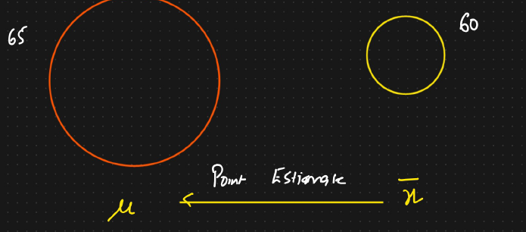

2. Interval Estimate: A range of values is used to estimate unknown population parameter.

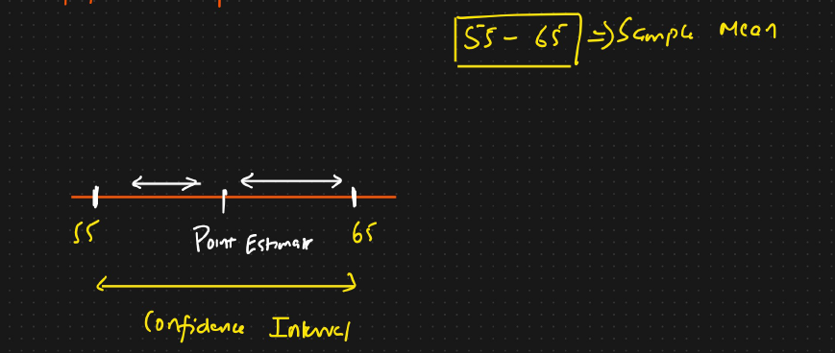

Gives a margin of error.

The range is called as the confidence interval.